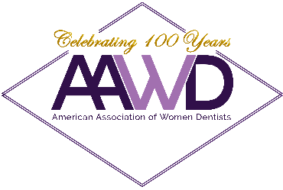
2022-2023 AAWD BOARD OF DIRECTORS NOMINATION FORM

The American Association of Women Dentists is seeking candidates to serve two-year terms on the 2022-2023 AAWD Board. You may nominate yourself or someone else using this form. Multiple nominations are permitted.

AAWD board members work together to advance women in dentistry. The Nominations Committee is currently seeking candidates who will bring wisdom, effectiveness, candor, and creative thinking to the board. In choosing nominees to develop the election slate, the Nominations Committee considers candidates’ backgrounds and experiences in five areas:

- Contributions to dentistry
- Strategic planning experience
- Leadership experience
- Experience assessing and administering finances
- Corporate relations experience

The open board positions for this term are as follows: President Elect, Secretary/Treasurer, Director of Member Benefits, Director of Membership and Chapters, and Director of Academic Affairs. Please note that there is a partial travel stipend included for AAWD Board Members.

2022-2023 AAWD Board Member Nomination Form
Nominee Information
Nominee’s Name:
Nominee’s Email: |  | Phone:
Position to Fill:
Nominator Information
Nominator’s Name:
Nominator’s Email: |  | Phone:

Resume: Please attach nominee’s current resume or CV to this nomination form.
The deadline for nominations is July 31, 2021.

Please return this nomination form and nominee’s resume or CV to: Rachel Jollie (rachel.jollie@internationalamc.com), cc: Dr. Brittany Bergeron, (bwbergerondds@gmail.com) by July 31, 2021.

