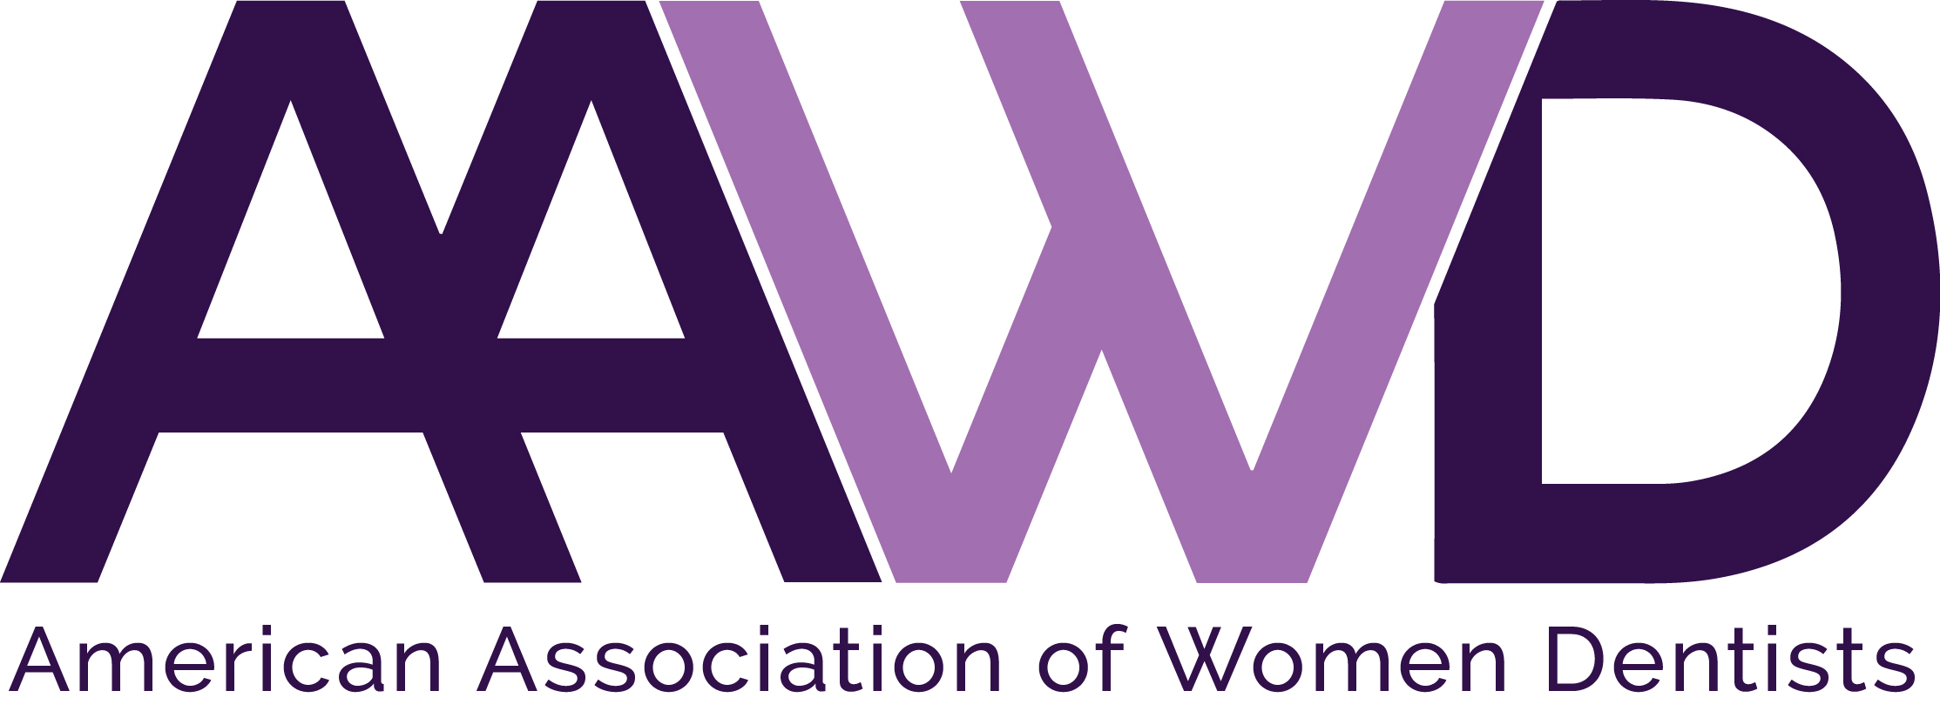
2022 Jeanne Hansen Bayless Uniformed Services Award

The American Association of Women Dentists presents the Jeanne Hansen Bayless Uniformed Services Award to recognize the lifetime achievements made by a woman dentist in the Uniformed Services arena. Application instructions for this award are listed below.

Each year AAWD accepts Uniformed Services Award nominations for a woman dentist who:
- Has made outstanding achievements in the Uniformed Services arena as a uniformed dental officer, Active duty, Reserve, National Guard or Retired dental officer member from one of the seven uniformed services that commission officers as defined by Title 10 and subsequently structured and organized by Title 10, Title 14, Title 32 and Title 42 of the United States Code: United States Army, United States Marine Corps, United States Navy, United States Air Force, United States Coast Guard, United States Public Health Service Commissioned Corps, and the National Oceanic and Atmospheric Administration Commissioned Officer Corps.
- Exhibits role model qualities that positively reflect the image of women dentists and commitment to the profession.

Nominee eligibility requirements:
- Current AAWD member in good standing and history of full membership in AAWD for at least five (5) years.
- Service as a Federal Service uniformed dental officer as follows: Active duty, Reserve, National Guard or Retired dental officer member from one of the seven uniformed services that commission officers as defined by Title 10 and subsequently structured and organized by Title 10, Title 14, Title 32 and Title 42 of the United States Code: United States Army, United States Marine Corps, United States Navy, United States Air Force, United States Coast Guard, United States Public Health Service Commissioned Corps, and the National Oceanic and Atmospheric Administration Commissioned Officer Corps.
- Nominee must not have been a member of the AAWD Board of Directors during the past two calendar years.
Nominator must submit the following:
- Application form
- Nominee’s curriculum vitae (CV)
  - Please denote education on CV to include degrees earned at institutions of higher learning. Listing individual continuing education (CE) accomplished is discouraged. If it is a true statement, please enter a statement on the CV: “I have completed the CE necessary to meet licensure requirements for [enter name of state or governmental unit]”. This includes those whose states do not require them to complete CE when on active uniformed service status – AAWD understands that to be the case.
  - Please denote on CV membership in Professional Organizations (does not necessarily mean just dental ones, but can include Uniformed Services associations, community ones such as the American Legion, etc.).
  - Please list awards received on CV.
  - NOTE: for those claiming Reserve or National Guard service, please indicate on CV both years of active Reserve or National Guard service and denote any time recorded on DD214's by giving inclusive dates.
- Letter of recommendation on behalf of nominee, explaining reasons for nomination including mentoring and advocacy efforts and involvement in AAWD.

To nominate an AAWD member deserving of this award, complete the nomination form following and return it to the AAWD National Office, along with a recommendation letter detailing why the nominee should be selected, as well as the nominee’s curriculum vitae.

Please forward all nomination materials to the AAWD National Office no later than
July 31, 2022.

If you have any questions, please call the AAWD National Office at 1-800-920-2293.

NOTE: These are instructions for the Uniformed Services Award. There is also a Federal Services Award for those dentists who serve the federal government in a civilian or non-uniformed capacity and there is a separate set of instructions for that award.

AAWD 2022 JEANNE HANSEN BAYLESS
UNIFORMED SERVICES AWARD APPLICATION
Please fill out all information completely and legibly.
Nominator Information
Nominator’s Name:
Nominator’s Address:
Nominator’s City, State, Zip:
Nominator’s Telephone:
Nominee Information
Nominee’s Name:
Nominee’s Address:
Nominee’s City, State, Zip:
Nominee’s Telephone:
Nominee’s Email Address:

Your completed application should consist of:
- This application form as the first part of your packet.
- Nominator’s typed letter of recommendation explaining reasons for nomination (include information pertaining to nominee’s mentoring and advocacy efforts).
- Nominee’s current CV.

Completed applications must be received by AAWD National Office by July 31, 2022.

Email: awards@aawd.org
Fax: 850-484-8762
Mail: American Association of Women Dentists
National Office
7794 Grow Drive
Pensacola, FL 32514-7072
The Mission of the American Association of Women Dentist:
To be the leading resource for advancing, connecting, and enriching the lives of women dentists.

